Section 1:

**Problem:** Project 4 - This phase involves adding persistence to the RollManager

that we developed in the previous phase of our project. We will preserve the data in a text file that we can restore the next time we use the Roll Manager by reading the data from the text file.

Section 2:

Inputs

* Main menu selection(cannot be 0 or negative. Should be between 1 and 10)
* A student’s information
  + Last Name
  + First Name
  + Major
  + Classification
  + Hours Completed
  + GPA
  + JPG File
* Menu option for which student to drop or edit
* The student that the user wants to display
* Pipe delimited Text File containing the Student’s information

Outputs

* Main Menu
* Prompts for student info
* Display all Students and info
* Display a menu of students to decide which to drop, edit, or display
* Display student info
* Send information to a text file

Processing

* Sort the Students by gpa or name
* Search for a certain Student to display
* Search for a student by classification and display info
* Take in information from file, and be able to do methods on these things, then output it to another file

Section 3:

**Class Name:** Student

To give us the ability to make Student objects to store their first name, last name, major, classification, gpa, hours completed, and a jpg file. It should have getters and setters for our attributes, and it will have a few basic constructors. It will also have a toString method.

**Class Name:** Classification

This class is used to create an enum to be used in the other classes.

**Class Name:** RollManager

Maintains an arrayList of Students named classRoll and provides methods that manage

the collection. Also has Strings to store courseNumber, courseName, and instructor. Will have constructors, getters, setters, and toString methods along with methods such as get, set, size, and remove so that the driver can work with individual Students from classRoll. Also reads the information in from a file, and it outputs it to a new file. Also handles all exceptions. Must be able to save the information and choose files using JFileChooser.

**Class Name:** ClassRollDriver

The Driver class will display a main menu which has 10 options. It will have the option to create a course, to Create a new Student object and add it to the RollManager’s classRoll, to Edit an existing Student from the RollManager’s classRoll, to drop a student from the classRoll, to display all students from the classRoll, to find and display a student by name, to display all students on the classRoll of a given Classification, to sort the students by name, to sort the Students by GPA, or to exit.

Section 4: 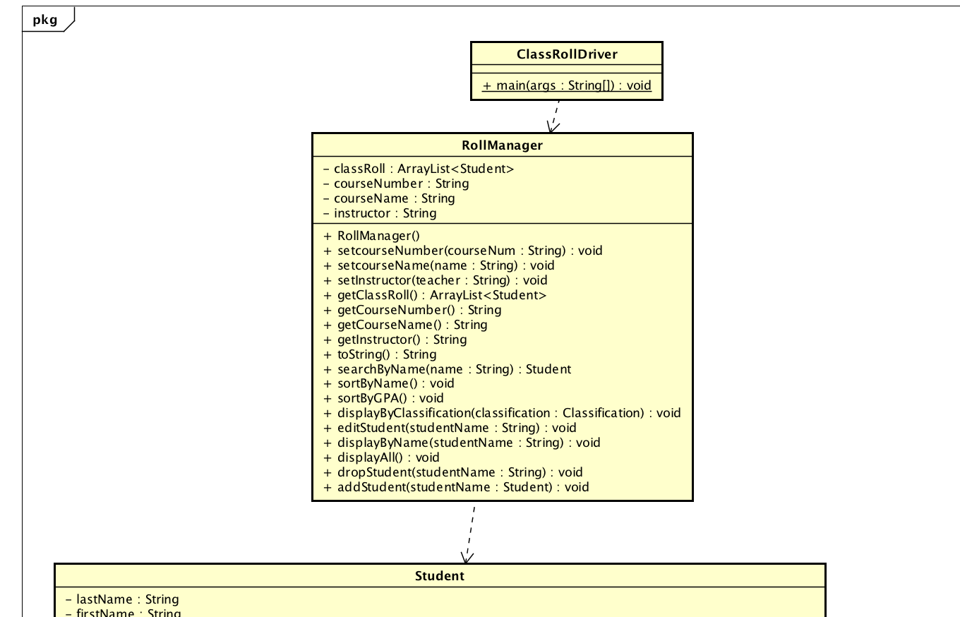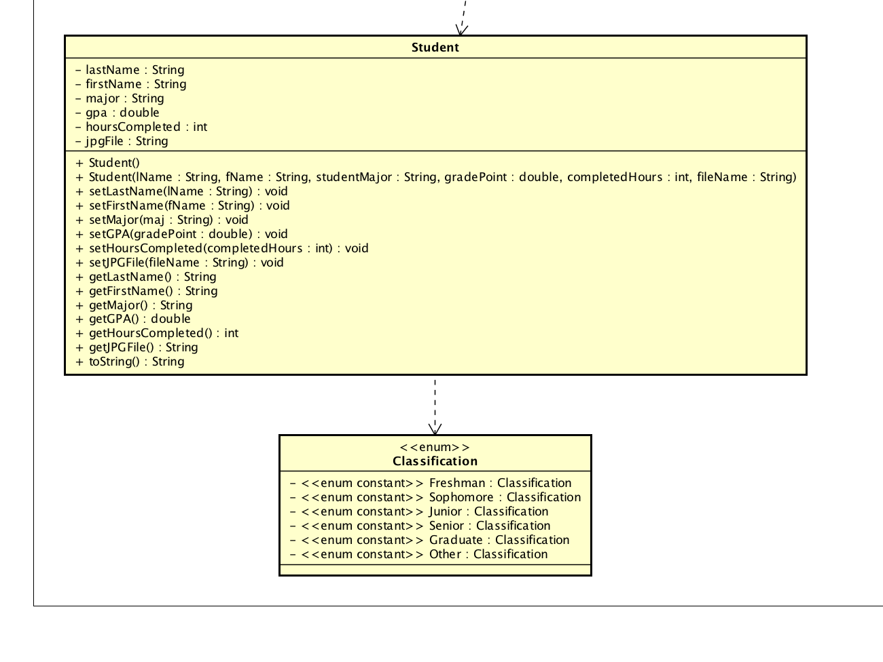

Section 5:

DRIVER –

main method

Declare variables and initialize

Create Scanner object to read in information from the text file

Create PrintWriter object to write information to a file.

Use JFileChooser to allow user to choose which file to open from and save to.

Display main menu

1. Create a new course for the class Roll Manager
2. Create a new Student object and add it to classRoll using addStudent
3. Edit an existing Student by using the editStudent method
4. Drop a student from classRoll using dropStudent method
5. Display all students using displayAll method
6. Find and display a student by name by searching for name then displaying info
7. Display all of a Classification by using displayByClassification method
8. Sort the students by name by using the sortByName method
9. Sort the students by gpa by using the sortByGPA method
10. Exit the program

Also have choices to fill from file and save to file

Prompt for user’s menu entry

Validate that, then use that to decide which option to do

Repeat until the user inputs 10

ROLLMANAGER -

Create attributes and initialize them.

Use try, catch blocks throughout the code to catch exceptions and save the file when exiting the program

addStudent method:

either pass in a student object and copy its attributes to a new student object or prompt for info from the user and create a new object

editStudent method:

pass in a student’s name, then find that student. After finding that student, prompt the user for the Student’s new info to set

dropStudent method:

pass in a student’s name, then find the student and remove them from the arraylist

displayAll method:

loop through the arrayList and display every Student

searchByName method:

pass in a name, then search through the arraylist for it and return that student’s info.

displaybyClassification method:

pass in a classification, then loop through the arraylist and display if classification = the classification passed in

sortByName method:

loop through the arrayList and move the highest letter to the bottom and continue to the end using a selection sort

sortByGPA method:

loop through the ArrayList and move the highest gpa to the bottom of the list using selection sort

STUDENT

Declare attributes

Getters/setters/constructors

CLASSIFICATION

Create enum values

SECTION 6:

|  |  |
| --- | --- |
| Menu Selection | Expected Output |
| -15 | Invalid |
| 0 | Invalid |
| 1 | Option 1 |
| 2 | Option 2 |
| 3 | Option 3 |
| 4 | Option 4 |
| 5 | Option 5 |
| 6 | Option 6 |
| 7 | Option 7 |
| 8 | Option 8 |
| 9 | Option 9 |
| 10 | Option 10 |
| 11 | Invalid |

|  |  |  |
| --- | --- | --- |
| **Student 1** |  |  |
| Prompts | Input | Expected Output |
| Last Name | Cowell | Cowell |
| First Name | Dakota | Dakota |
| Major | CSCI | CSCI |
| Classification | Freshman | Freshman |
| Hours Completed | 12 | 12 |
| GPA | 4.0 | 4.0 |
| JPG File | jimmy.jpg | jimmy.jpg |
|  |  |  |
| **Student 2** |  |  |
| Prompts | Input | Expected Output |
| Last Name | Cockrell | Cockrell |
| First Name | Morgan | Morgan |
| Major | math | MATH |
| Classification | SOPHOMORE | Sophomore |
| Hours Completed | -3 | invalid |
| GPA | 3.89 | 3.89 |
| JPG File | WATER.jpg | WATER.jpg |
|  |  |  |
| **Student 3** |  |  |
| Prompts | Input | Expected Output |
| Last Name | PECORINI | PECORINI |
| First Name | MATT | MATT |
| Major | xxxx | XXXX |
| Classification | junior | Junior |
| Hours Completed | 0 | 0 |
| GPA | 2.4 | invalid because 0 hours completed |
| JPG File | Stupid.jpg | Stupid.jpg |
|  |  |  |
| **Student 4** |  |  |
| Prompts | Input | Expected Output |
| Last Name | James | James |
| First Name | matt | matt |
| Major | csc | Invalid |
| Classification | Senior | Senior |
| Hours Completed | 40 | 40 |
| GPA | 40 | invalid. Too high of a number |
| JPG File | Water.jpg | Water.jpg |
|  |  |  |
| **Student 5** |  |  |
| Prompts | Input | Expected Output |
| Last Name | Munsey | Munsey |
| First Name | Morgan | Morgan |
| Major | digm | DIGM |
| Classification | Graduate | Graduate |
| Hours Completed | 150 | 150 |
| GPA | 2.7 | 2.7 |
| JPG File | Sleepy | Sleepy |
|  |  |  |
| **Student 6** |  |  |
| Prompts | Input | Expected Output |
| Last Name | Banana | Banana |
| First Name | Fred | Fred |
| Major | cScI | CSCI |
| Classification | Other | Other |
| Hours Completed | -412 | invalid |
| GPA | -62 | invalid |
| JPG File | stupid.jgp | stupid.jgp |
|  |  |  |
| **Student 7** |  |  |
| Prompts | Input | Expected Output |
| Last Name | Rain | Rain |
| First Name | Music | Music |
| Major | Nothing | Invalid. Too long |
| Classification | Banana | Invalid |
| Hours Completed | 0 | 0 |
| GPA | 0 | 0 |
| JPG File | Dc.jpg | Dc.jpg |

Input Text File

MATH1234 | Linear Algebra | Cintron

Dakota | Cowell | CSCI | Freshman | 12 | 4.0 | jimmy.jpg

Morgan | Cockrell | math | SOPHOMORE | -3 | 3.89 | WATER.jpg

MATT | PECORINI | xxxx | junior | 0 | 2.4 | Stupid.jpg

matt | James | csc | Senior | 40 | 40 | Water.jpg

Morgan | Munsey | digm | Graduate | 150 | 2.7 | Sleepy

Fred | Banana | cScI | Other | -412 | -62 | stupid.jpg

Music | Rain | Nothing | Banana | 0 | 0 | Dc.jpg

Adam | Klinker | CSCI | Junior | 32 | 3.32 | Adam.jpg

Cameron | Hashmi | MRKT | Senior | 134 | 1.4 | Camo.jpg

Colby | Ross | NONE | Graduate | 77 | 3.48 | Colb.jpg

Output Text File

MATH1234 | Linear Algebra | Cintron

Dakota | Cowell | CSCI | Freshman | 12 | 4.0 | jimmy.jpg

Morgan | Cockrell | MATH | Sophomore | Invalid | 3.89 | WATER.jpg

MATT | PECORINI | XXXX | junior | 0 | Invalid | Stupid.jpg

matt | James | Invalid | Senior | 40 | 40 | Water.jpg

Morgan | Munsey | DIGM | Graduate | 150 | 2.7 | Sleepy

Fred | Banana | CSCI | Other | -412 | invalid | stupid.jpg

Music | Rain | Nothing | Banana | 0 | 0 | Dc.jpg

Adam | Klinker | CSCI | Junior | 32 | 3.32 | Adam.jpg

Cameron | Hashmi | MRKT | Senior | 134 | 1.4 | Camo.jpg

Colby | Ross | NONE | Graduate | 77 | 3.48 | Colb.jpg